Page 27

Q. 48

$Σ= \left\{ 0,1,2 \right\}$

1. No
$v=001:q_{0}→q_{1}→ q_{2}→q_{5}$

$v=11: q_{0}→q_{3}→ q_{6}$

3. $L=\left\{ v \right| \#_{0}\left(v\right)=2, \#_{1}\left(v\right)=1 \}$ Contains exactly twice '2' and exactly one '1'.

Q. 49

$Σ=\{ a,b,c \}$

1. No
$v=ab:q_{0}→q_{1}→q_{2}$

$v=a: q_{0}→q_{1}$

2. Contains the sequence 'ab' and has at most 1 'c'.

Q. 50

$Σ=\left\{ 0,1,2 \right\}$

1. No

$v=021:q_{0}→q_{1}→q_{2}→q_{3}$

$v=0:q_{0}→q_{1}$

$L=\left\{ {02}^{2n+1}1 \right| n∈ N_{0}\}$

Q. 51

$Σ=\left\{ 0,1,2 \right\}$

1. No

$v=011:q_{0}→q_{1}→q_{2}→q_{3}$

$v=0:q_{0}→q_{1}$

$L=\left\{ 0^{n}{10}^{m}1 \right| n,m∈ N_{0} \}$

Page 40

Q. 1 (i)

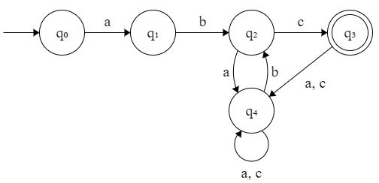

Q. 1 (ii)

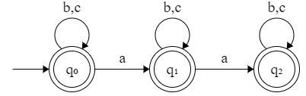

Q. 1 (iii)

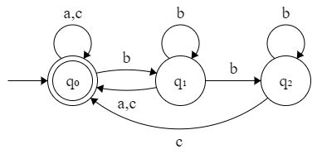

Q. 1 (iv)

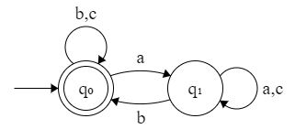

Q. 2

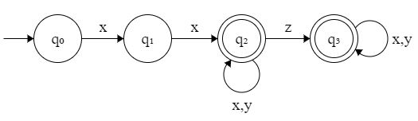

Q. 3

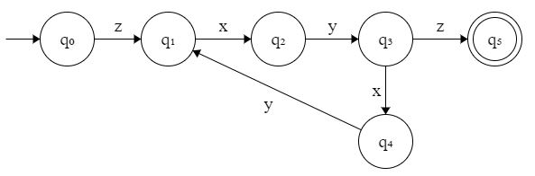

Q. 4

